**Offshore Application Development through a managed service provider for accelerated digital transformation**

**Managed Service Provider** is any company that provides services, be it IT Infrastructure or application development or any other related services, remotely on a proactive basis. Enterprise Touch is an application development **managed service provider** offering**offshore development services** for business acceleration through digital transformation.

**[Offshore Application Development](http://www.enterprisetouch.com/services/managed-services/)** through a capable partner like us will bring to the table the best of both worlds - one, flexibility like never before; two, the feel of having an extended arm to carry out **application development** with equal commitment.

Many **offshore application development** companies offer a variety of models depending on the client’s requirements. To dwell deep into the Enterprise Touch’s capabilities

We excel in IT services industry providing support in various aspects of enterprises. Our team always carries a passion to provide quality services on-time. Our turn-around-time has been commendable and we believe this helped organizations to achieve their goals faster.

We provide **offshore development services** through applications in Enterprise mobility and Web space to customers across the globe. Our proven strategy in IT Staffing & Development services eliminates risks the customers might face.

There are times when enterprises are unsure of adapting the project development timeline, having their own in-house team. Gathering our overall competence in handling enterprise applications, we understand the need for time and material management. We have a foolproof team hungry to prove their worthiness. We are a strong mobile shoulder to rely on with the needed secured network, infrastructure, talented and strong development & management teams.

We as a **[managed service provider](http://www.enterprisetouch.com/services/managed-services/)**, offer application development extension to businesses without making much noise, allowing organizations to focus better on their line of business.

**OUR VALUE PROPOSITION**

**Standardization** inline with International best practice

**Streamlined** process for exceptional service delivery

**Improved** communication channel with customers and stakeholder

**OUR KEY DIFFERENTIATORS**

Team with a wide range of functional and technical expertise

Share project risk equally and eliminate pitfalls

Responsible for the deliverable, anchored with SLAs

Quality focused on leading practices

Well-defined tasks and Project Management Processes

Single-source accountability integrated with business needs

Greater control over the process, quality, and management

Flexible and on-demand models

**Enterprise Touch Retainer Model - Key takeaways**

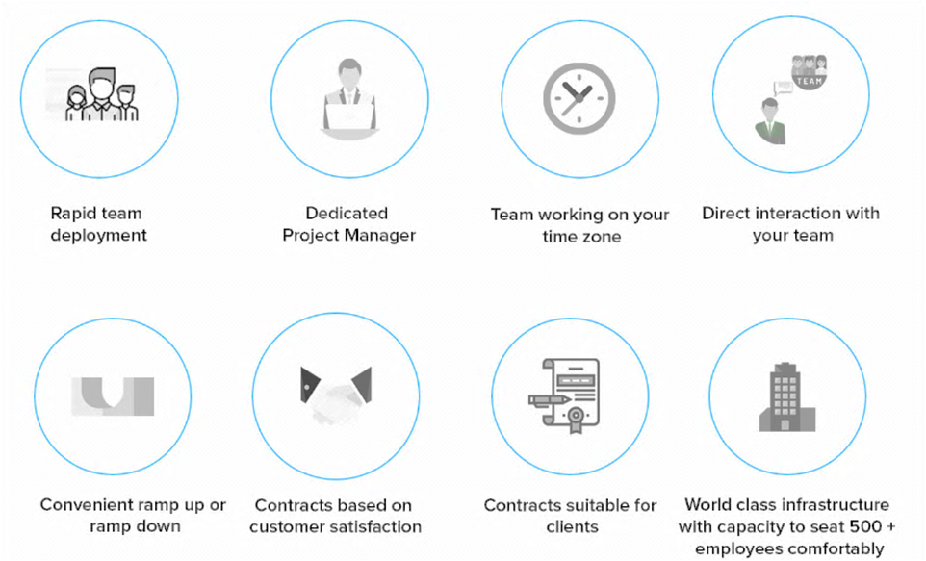

Ease of ramp up and ramp down of the team of qualified professionals based on the ongoing need, our dedicated team of staffing solutions professionals has proven methodologies to ensure our clients receive the best overall value, allowing them time to focus on their core competencies while meeting peak demands.

We help to raise the bar and bring transformation in every aspect of client business. With years of experience in extensive technology research, we offer our clients both Native and Cross Platform Enterprise-grade applications rapidly.

At Enterprise Touch, **[Digital Transformation](http://www.enterprisetouch.com/)**is custom-made to best suit the client’s needs. Get in touch today to know more.